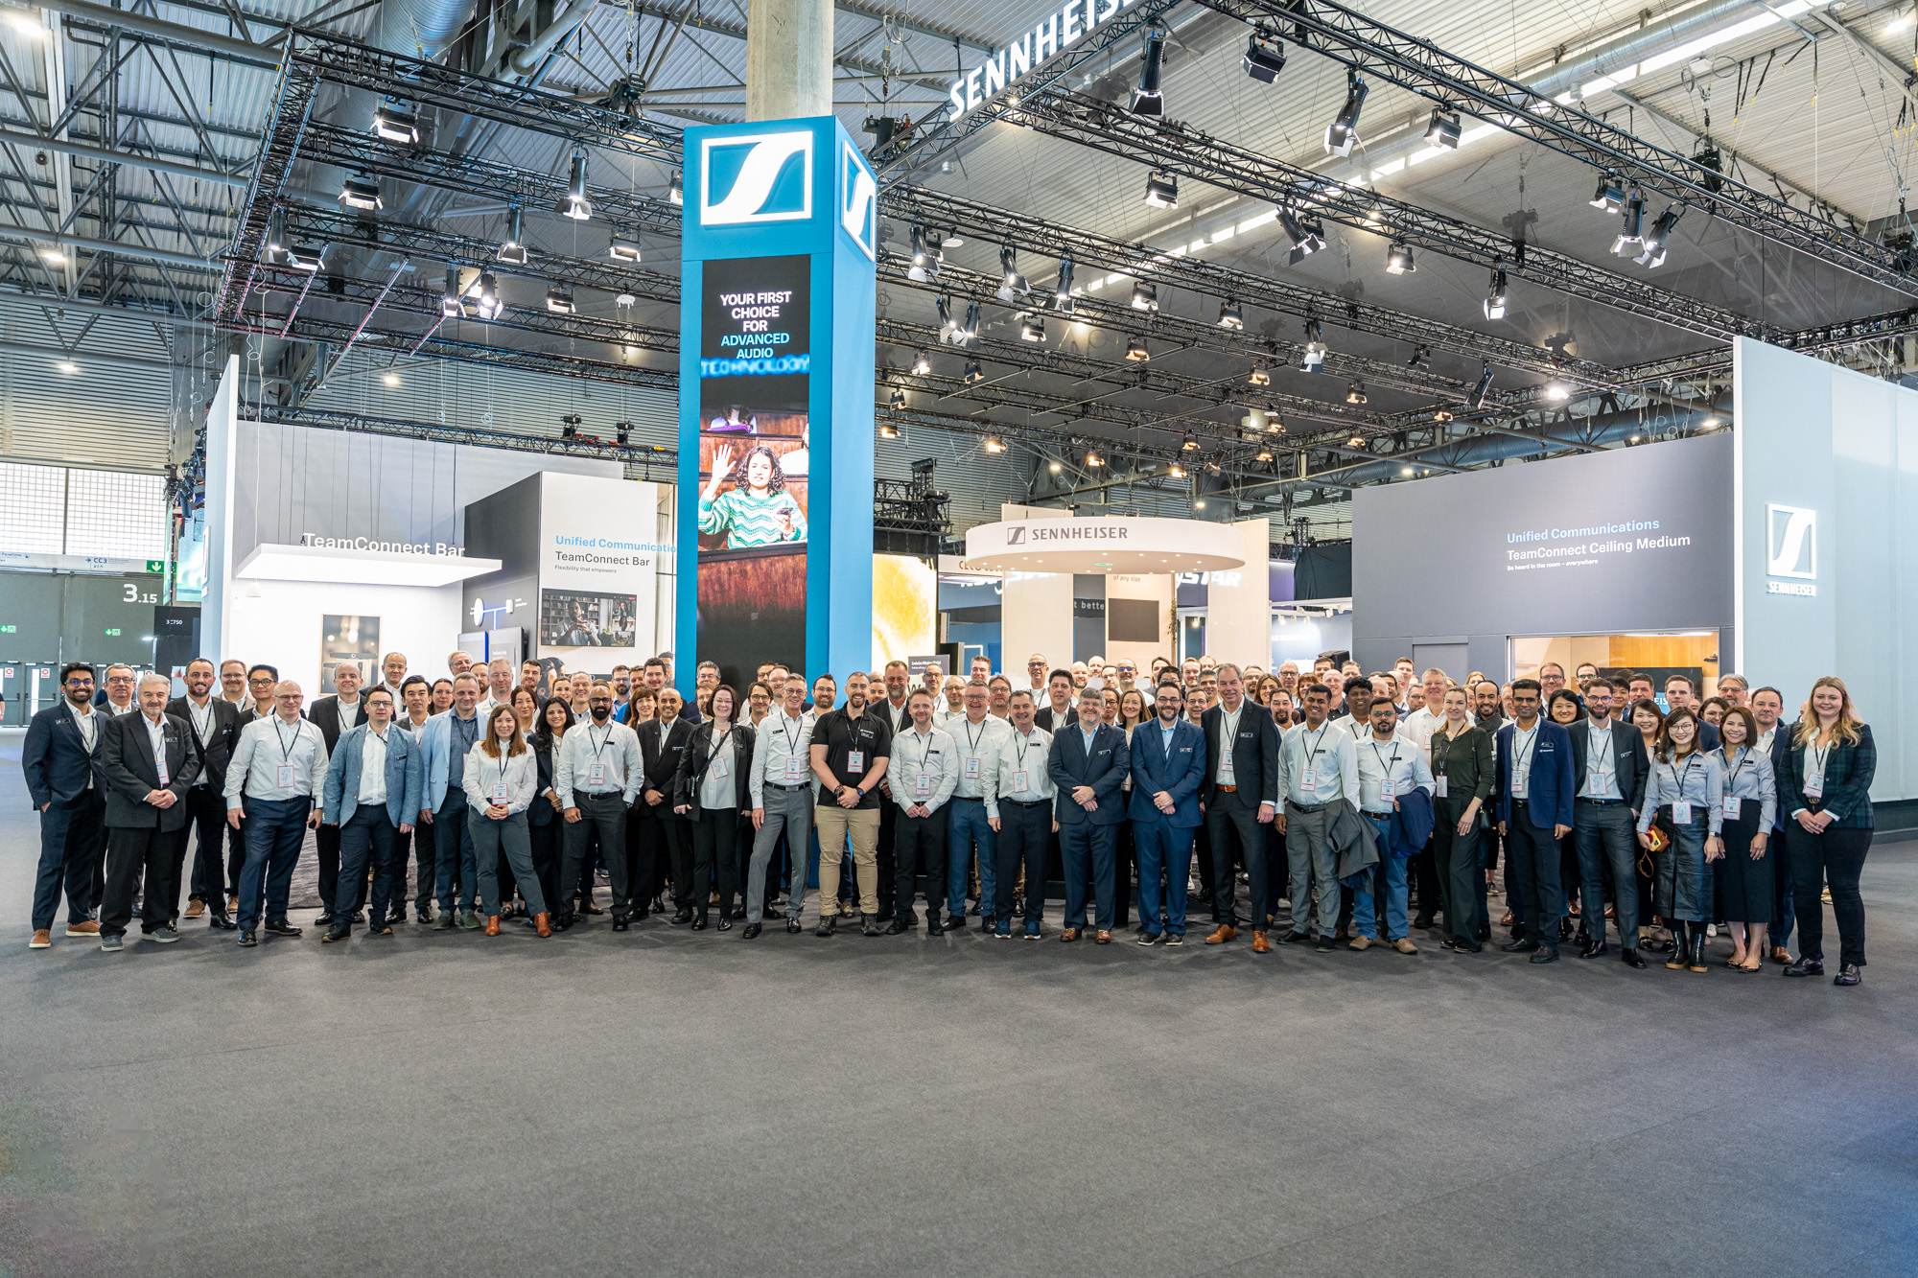
Discover the Sennheiser Group’s audio solutions at ISE 2025
Visitors will experience true innovation at Sennheiser’s largest ISE booth ever

Wedemark/Barcelona, January 2025 – At ISE 2025, the Sennheiser Group will present the expansive range of audio solutions and workflows of their brands Sennheiser, Neumann.Berlin, AMBEO and Merging Technologies for the educational, corporate, live audio, broadcasting and studio spaces. At Sennheiser’s adjacent booths in Hall 3, B500 and B550, ISE visitors will get closer than ever to the group’s complete portfolio and can experience the technologies in engaging demo rooms, with a team of passionate experts guiding them through.

The Business Communication Zone
The Business Communication Zone will showcase solutions for easy learning and collaboration, tailored for unified communication in lecture halls, boardrooms, and every space in between. Sennheiser’s popular live demo meeting rooms will showcase the TeamConnect (TC) Bar S and M – the most feature-rich all-in-one conferencing devices in their class – as well as the TeamConnect Ceiling Medium (TCC M) microphone, with its award-winning design and seamless sound, including automatic dynamic beamforming and TruVoicelift in action. Attendees can join the TC Bar demo every 20 minutes and the TCC M demo every 30 minutes during show hours.

Visitors will also have the opportunity to get hands-on with Sennheiser’s cutting-edge wireless solutions, featuring EW-DX, the latest addition to the Evolution Wireless Digital Family, and a live demo of MobileConnect, the bidirectional solution to hear clearly, respond effortlessly and interact live.

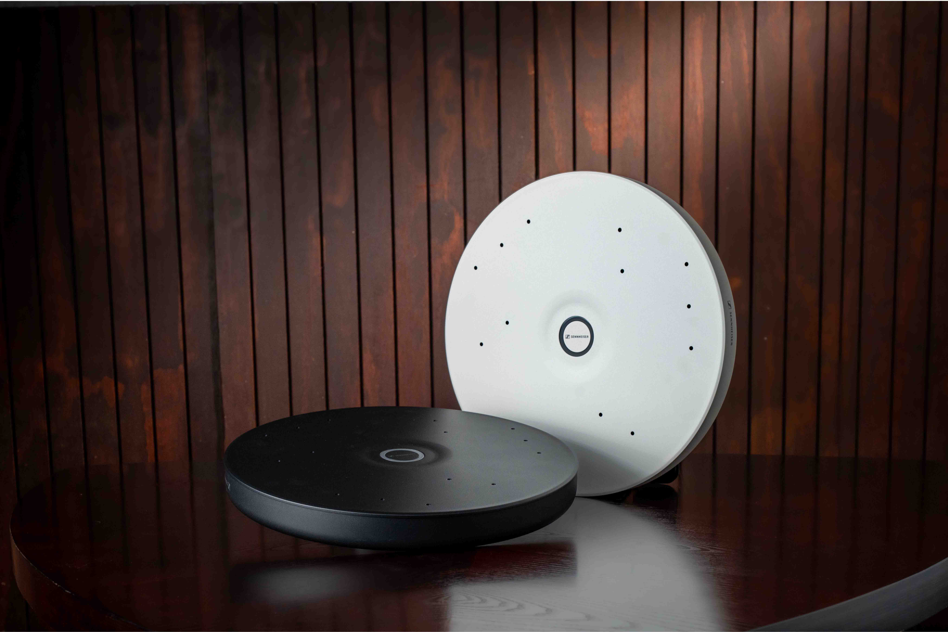
Sennheiser’s TeamConnect Family solutions

Join the ISE25 Hunt for your Perfect Pair
Sennheiser’s participation in ISE 2025 will also include the return of its popular, partner-involved Perfect Pair scavenger hunt. Enhanced with interactive tasks, cutting-edge technology, and exclusive prizes, this year’s hunt offers a dynamic way to explore how Sennheiser’s solutions integrate seamlessly with technologies from partner manufacturers.

Whether an integrator, consultant, or technology user, Sennheiser invites attendees to discover the full potential of its devices when paired with solutions from Global Partners and Alliances, showcasing how these collaborations deliver impactful systems for modern communication and collaboration.

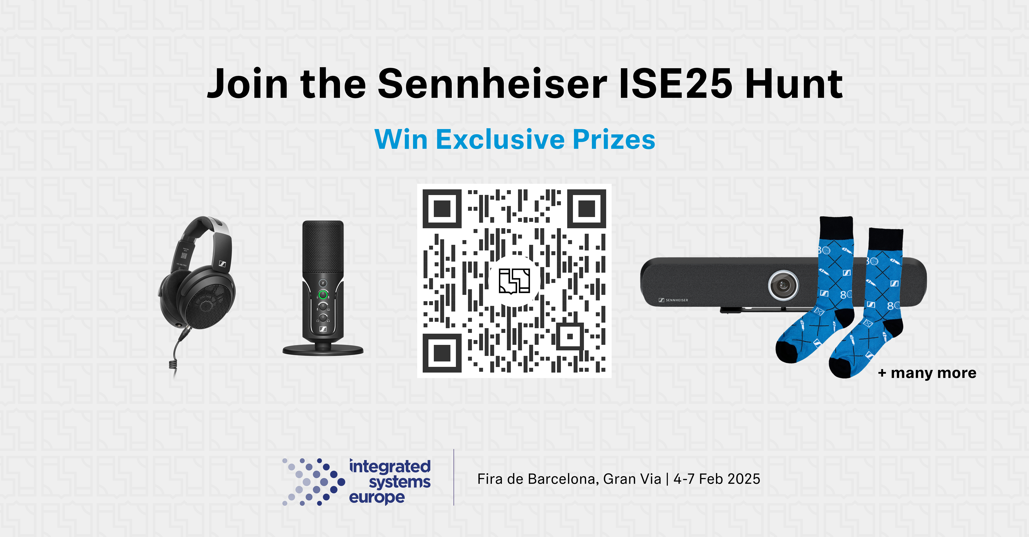 | ISE 2025 sees the return of the Perfect Pair scavenger hunt

To join the hunt, visitors should download the Scavify app from the App Store or Google Play, search for “ISE25” in the Scavify app and unlock the hunt. Find out more about the hunt and how to participate here.

The Professional Digital Wireless Zone
Sennheiser will provide deep dives into its bidirectional wideband Spectera ecosystem, which is based on the company’s decade-long research into Wireless Multichannel Audio Systems (WMAS) technology. Guests are invited to listen in to the system’s combined mic and IEM bodypacks, with Sennheiser RF experts on hand to answer questions about this ground-breaking technology.

The Spectera SEK bodypack handles both mic and IEM audio, plus control data, in the same wideband RF channel | 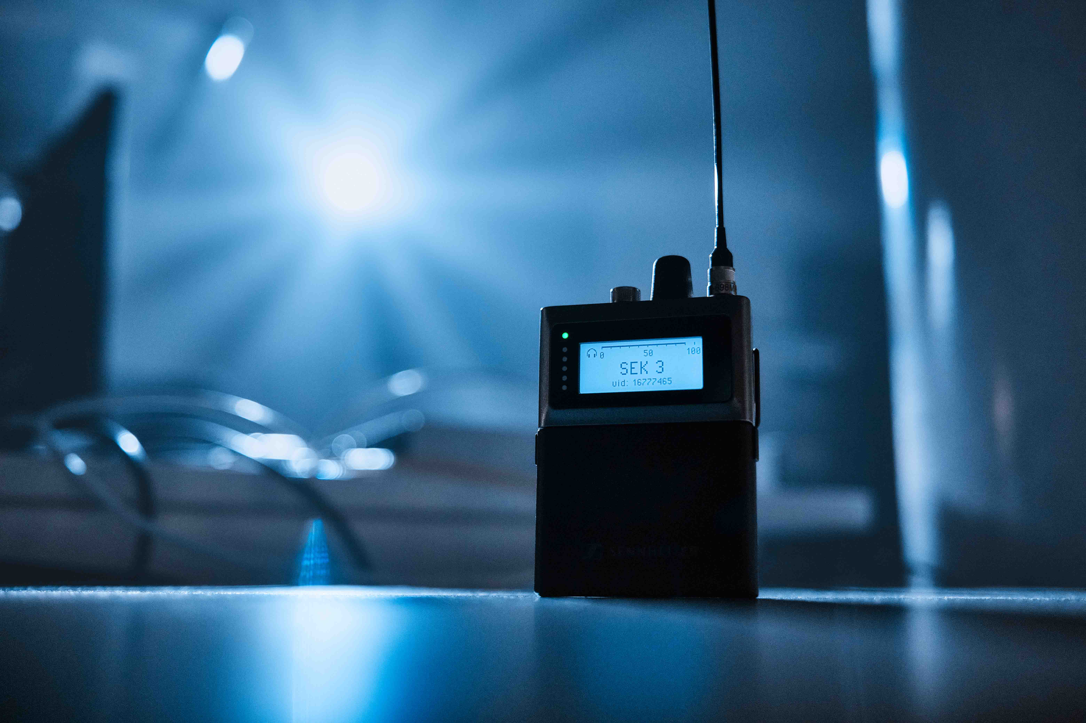

The company’s narrowband digital solutions Digital 6000 and EW-DX with the new four-channel Dante receiver will also be on display, with an associated “mic play table” providing guests with the rare opportunity to try out all available Sennheiser and Neumann capsules with a handheld, as well as head-worn and lavalier mics with a bodypack transmitter to find the ideal combo for their voice. Listening is via the Sennheiser HD 490 PRO and Neumann NDH 30 studio headphones.

On the wired side, Sennheiser will display its best microphone series, the MKH RF condenser microphone line with the latest addition, the MKH 8030 figure-of-eight microphone. Alongside the MD 435, the high-rejection MD 445 as well as the evolution e 935 and 945 vocal microphones, the MD 421 Kompakt – the mic for anything – will be part of the ISE showcase, as will the HMD broadcast headsets.

The Immersive Zone featuring studio monitoring solutions from Neumann
Neumann will present its innovative reference monitoring solutions in the Immersive Zone of the Sennheiser Group booth. The setup will include Neumann’s renowned KH line of studio monitors as well as the MT 48 audio interface running the Monitor Mission. Also, Neumann will preview an all-new product: RIME - Reference Immersive Monitoring Environment. RIME is a plug-in for DAWs, enabling users to monitor immersive formats such as Dolby Atmos 7.1.4 via headphones using novel AMBEO algorithms. In contrast to existing solutions, RIME is tailor-made for Neumann NDH 20 and NDH 30 headphones. In fact, the software incorporates an entire Neumann signal chain of KH speakers, perfectly aligned via MA 1 in a reference room, captured using the KU 100 binaural head via the MT 48. The result is ultimate sound quality and precision. RIME can also be used for externalization of stereo playback, making headphones sound like studio monitors.

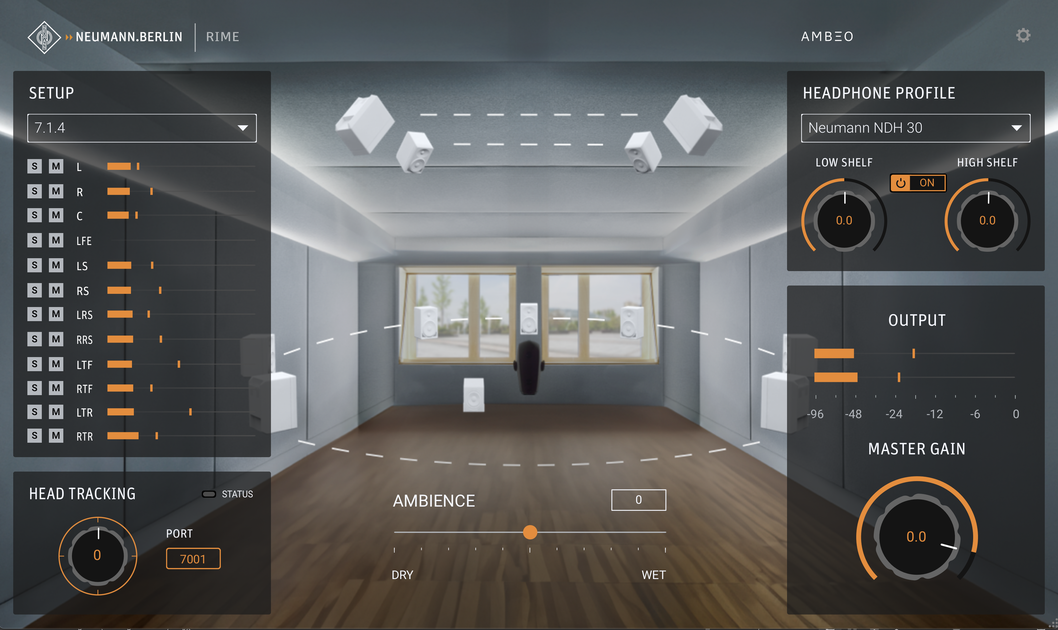
Neumann’s new DAW plugin RIME (Reference Immersive Monitoring Environment)

In addition, Neumann will be part of the Audio Content Creation Zone, showcasing the MT 48’s mobile recording capabilities. Being class-compliant, the MT 48 can record in highest audio quality to an iPad or iPhone. For mobile use, the MT 48 can be powered from a USB power bank (min. 25 W). Also shown will be Made-to-Order products including KH monitors as well as microphones in various colours.

Merging Technologies unveils Ovation 11 and showcases advanced Dante® integration
Merging Technologies is thrilled to unveil Ovation 11, the latest evolution of its flagship show synchronizer and media player. Designed for live events, theme parks and multimedia productions, Ovation 11 offers enhanced performance and innovative features that streamline control, synchronization, and playback for complex setups.

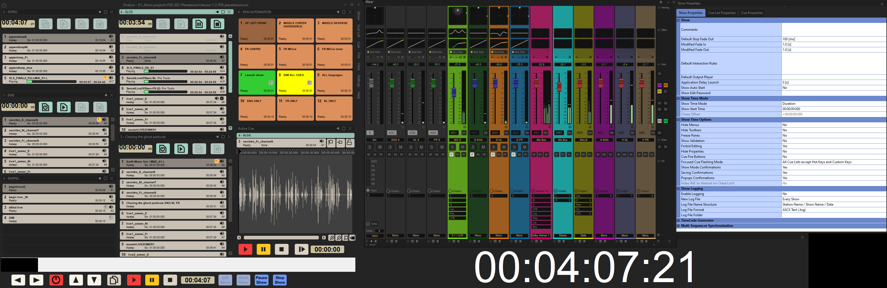
Ovation 11 preview mix and show control

Visitors will also experience Merging's cutting-edge Dante®-enabled ecosystem, featuring the Hapi Mk III, Anubis, and MT 48, seamlessly integrated with the Pyramix 15 DAW. This setup demonstrates how Merging is advancing audio production, offering unmatched precision, scalability, and flexibility in networked environments.

Visit the Sennheiser Group at ISE, Fira Barcelona, 4 to 7 February 2025, Hall 3, Stands B 500 and B 550.

(Ends)

The high-resolution images accompanying this media release can be downloaded here.

About the Sennheiser Group
Building the future of audio and creating unique sound experiences for our customers - this is the aspiration that unites the employees of the Sennheiser Group worldwide. The independent family-owned company Sennheiser was founded in 1945. Today, it is managed in the third generation by Dr Andreas Sennheiser and Daniel Sennheiser, and is one of the leading manufacturers in the field of professional audio technology.
sennheiser.com | neumann.com | dear-reality.com | merging.com

